Sensex Log Data Processing using Big-Data Tools

Data: Input Format - .PDF (Our Input Data is in PDF Format)
Like this below created 3000 records on my own
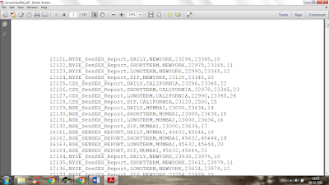
Input Dataset with attributes like:

Column | Description
1 | SENSEXID
2 | SENSEXNAME
3 | TYPEOFTRADING
4 | SENSEXLOC
5 | OPEN_BALANCE
6 | CLOSING_BAL
7 | FLTUATION_RATE

Problem Statement: Analyse the data in Hadoop Eco-system to:

1. Take the complete PDF Input data on HDFS

2. Develop a Map Reduce Use Case to get the below filtered results from the HDFS Input
data(Excel data)

If TYPE OF TRADING is -->'SIP'

- OPEN_BALANCE > 25000 & FLTUATION_RATE > 10 --> store "HighDemandMarket"
-CLOSING_BALANCE<22000 & FLTUATION_RATE IN BETWEEN 20 - 30 --> store "OnGoingMarketStretegy"

If TYPE OF TRADING is -->'SHORTTERM

- OPEN_BALANCE < 5000 --> store "WealthyProducts"
- SensexLoc --> "NewYork OR Mumbai" --> “ReliableProducts
else
store in "OtherProducts"

NOTE: In the mentioned file names only 5 outputs have to be generated

3. Develop a PIG Script to filter the Map Reduce Output in the below fashion

- Provide the Unique data

- Sort the Unique data based on SensexID.

4. EXPORT the same PIG Output from HDFS to MySQL using SQOOP

5. Store the same PIG Output in a HIVE External Table

